Router configuration

Step 1 :

Select the router ISR4321.

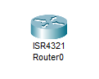

Step 2:

Place 2 switch beside the router.

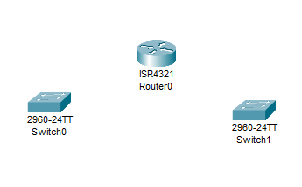

Step 3:

Place pc beside the switch.

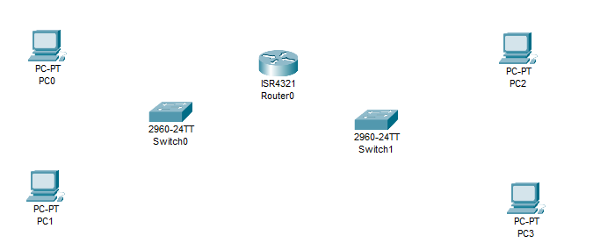

Step 4:

Now connect the switch and router with coper cross-over cable in gigabitEthernet1 and 2.

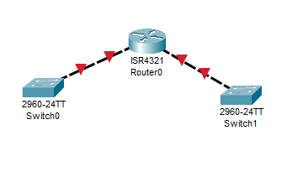

Step 5:

Now connect pc with switch coper straight-through.

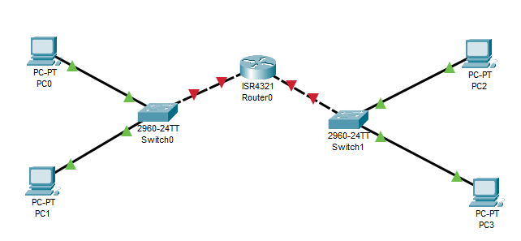

Step 6:

Now add IP address and gateway for all pc.

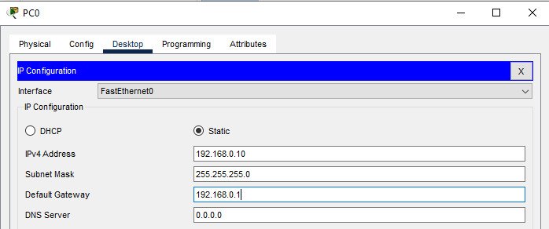

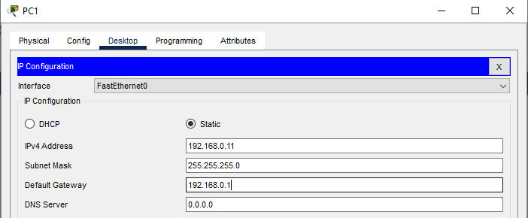

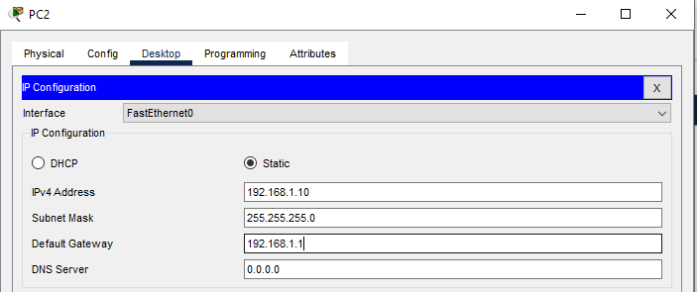

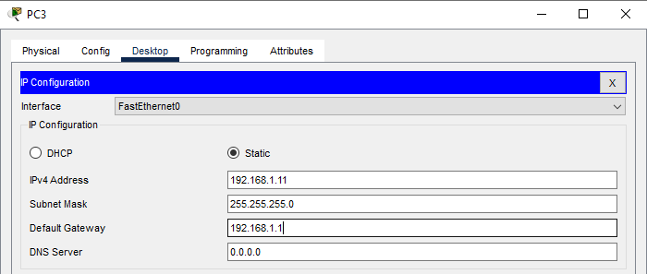

Step 7:

Now doing router config



**The first configuration command on any device should be to give it a unique hostname**

**Note**: To return the Router to the default prompt, use the **no hostname** global config command



**A banner message** is important to warn unauthorized personnel from attempting to access the device.

To create a banner message of the day on a network device, use the banner motd # the message of the day # global config command.



***Line Configuration Mode:***

*To move in and out of line configuration mode, use the* ***line*** *command followed by the management line type. To return to global configuration mode, use the* ***exit*** *command*



Security user EXEC mode access:

* first enter line console configuration mode using the “line console 0” command in global configuration mode.
* next specify the user EXEC mode password using the “password” password command.
* Finally enable user EXEC access using the login command.

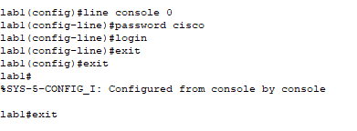

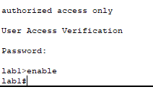

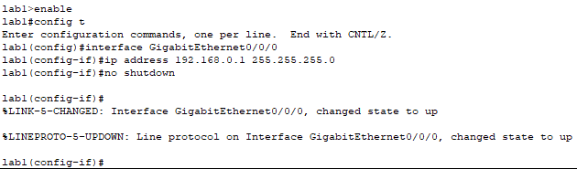

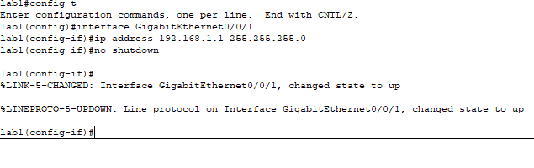

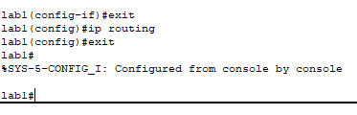

Securing VTY line access :

* First entre line VTY configuration mode using the line vty 0 15 command in global configuration mode
* Next, specify the vty password using the password command.
* Finally , enable VTY access using the logical command.

VTY lines enable remote access using Telnet or ssh to the device

lab1#

lab1#config t

Enter configuration commands, one per line. End with CNTL/Z.

lab1(config)#line vty 0 15

lab1(config-line)#password cisco

lab1(config-line)#login

lab1(config-line)#exit

lab1(config)#exit

lab1#

%SYS-5-CONFIG_I: Configured from console by console

**The startup-config and running-config files display most passwords in plaintext.**

**To encrypt all plaintext passwords, use the service password-encryption global config command.**

lab1#show running-config

Building configuration...

Current configuration : 698 bytes

!

version 15.4

no service timestamps log datetime msec

no service timestamps debug datetime msec

no service password-encryption

!

hostname lab1

!

!

!

!

!

!

!

!

ip cef

no ipv6 cef

!

!

!

!

!

!

interface GigabitEthernet0/0/1

ip address 192.168.1.1 255.255.255.0

duplex auto

speed auto

!

interface Vlan1

no ip address

shutdown

!

ip classless

!

ip flow-export version 9

!

!

!

banner motd ^Cauthorized access only^C

!

!

!

!

line con 0

password cisco

login

!

line aux 0

!

line vty 0 4

password cisco

login

line vty 5 15

password cisco

login

!

**end**

**To encrypt all plaintext passwords, use the service password-encryption global config command.**

lab1#configure terminal

Enter configuration commands, one per line. End with CNTL/Z.

lab1(config)#service password-encryption

lab1(config)#exit

lab1#

lab1#

%SYS-5-CONFIG_I: Configured from console by console

**Use the show running-config command to verify that the passwords on the device are now encrypted**

lab1#show running-config

Building configuration...

Current configuration : 722 bytes

!

version 15.4

no service timestamps log datetime msec

no service timestamps debug datetime msec

service password-encryption

!

hostname lab1

!

!

!

!

!

!

!

!

ip cef

no ipv6 cef

!

!

!

!

!

!

!

!

!

!

!

!

spanning-tree mode pvst

!

!

!

!

!

!

interface GigabitEthernet0/0/0

ip address 192.168.0.1 255.255.255.0

duplex auto

!

speed auto

interface GigabitEthernet0/0/1

ip address 192.168.1.1 255.255.255.0

duplex auto

speed auto

!

interface Vlan1

no ip address

shutdown

!

ip classless

!

ip flow-export version 9

!

!

!

banner motd ^Cauthorized access only^C

!

!

!

!

Line con 0

password 7 0822455D0A16

login

!

line aux 0

!

line vty 0 4

password 7 0822455D0A16

login

line vty 5 15

password 7 0822455D0A16

login

!

!

!

end

lab1#copy running-config startup-config

Destination filename [startup-config]?

Building configuration...

[OK]

lab1#

**Reload the device using the reload command in privilege EXEC mode. Note: This will cause the device to briefly go offline, leading to network downtime.**



**If the undesired changes were saved to the startup-config, it may be necessary to clear all the configurations using the erase startup-config command in privilege EXEC mode.**

• **After erasing the startup-config, reload the device to clear the running-config file from RAM.**

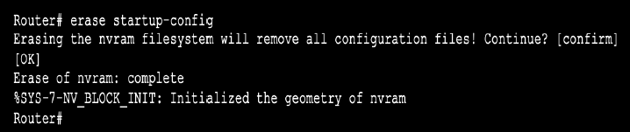

**Ping from PC0 to PC2**



**Ping from PC1 to PC3**

